**Skeleton-Based Action Recognition Using Few Shot Learning**

**Wangbin Ding1,2, Shengqin Lin2, Zhenze Dai2**

1Shanghai JJ Software Technology Co 2Fuzhou Institute of Technology

Abstract

This paper presents a new action recognition method using the few shot learning. considered the skeleton sequence contain the temporal and spatial information, the proposed method encodes each of skeleton feature as an RGB image. Then a few shot learning method, prototypical network, is introduced to recognize the specific action of the RGB image stands for. Since a serial of dilated-densenet layers is utilized to map the feature image into embedding space, our method could extend the receptive field of feature points to the skeleton sequence (RGB image) without reducing the details information of skeleton points (resolution of feature map), Experiment result shows, our method achieved state-of-the art performance on the UTD-MHAD dataset.

**Index Terms:** skeleton sequence, dilated filter, few shot learning

# Introduction

Human action recognition has been widely researched for few decades. A lot of recognition methods are developed to serve the field of entertainment, surveillance and video analysis.

From the perspective of feature representation, these recognize methods could divide into three kinds: first, local feature-based method. Such methods design a set of 3D local invariant descriptor (3D-Hessia and 3D-Harris) to track the movement of human body. Then a machine learning model will be engaged to recognize the indeed action of the movement. Second, global feature-based method. It usually needs a descriptor to capture the whole motion of human body. Motion Energy Image (MEI) and Motion History Image (MHI) are two typical of global descriptor. The last type method is developed by the latest wave of deep learning model. Or it could interpret as a mixture of local and global feature descriptor method. deep learning models like 3D-CNN[1] and LSTM[2] had achieved state of the art performance in the action recognition filed. But these methods always consume large-scale datasets during training time. as human actions are varied, the demand of train sample will be exploded. Besides, when feed a new class of sample, the deep model need be re-trained to fit the changing distribution of the data.

To address these difficulties, a kind of Few-shot learning method are proposed. Non-parameter model from nearest neighbor to metric learning [3] have play a great role in the progress of this field. But seldom attention had paid to apply the few shot learning model to action recognition yet. for these reasons, we propose a method based on the few shot learning and global skeleton feature. Our method could also be considered as a kind of the global feature representation method. And The main contributions of this method are：

1. Only few skeleton sequences are needed to train an efficient action recognition model.
2. With few support samples, it is enough to recognize the action that had never seen before.
3. Dilated filter is embedded to extract the feature map, which could enhance the robustness and diversity of our feature representation.

The remainder of the paper is organized as follows. In Sec.2 we briefly review methods proposed to deal with skeleton representation, dilation filter and few shot learning. In Sec. 3 we describe the above action recognition method. In Sec. 4 In Sec. we report the experiments results on a series of dataset. Finally, in Sec.5 we discuss propose research directions in the future.

# proposed method

## Feature image

It is common knowledge that a skeleton sequence can be represented as an RGB image []. consider a frame skeleton sequence , each contains joints . And each is a 3-D coordinate point, which is corresponding to the RGB channel of a pixel in image . Thus, the skeleton sequence can be encoded as an feature image. a sort of variant RGB encoder had proposed to achieve the translation-scale invariant representation of the skeleton sequences [4][5]. But our method hasn’t taken advantage of these mechanism. Only a normalization, proposed by [6], is introduced.

Where and are the maximum and minimum value of the k-th channel (x; y; z) of the i-th skeleton.



Figure 1. the workflow of extracting a feature image from a skeleton sequence

## Prototypical network

A prototypical network[7] learn a metric space in which classification can be performed by computing distances to prototype representations of each class[7]. given K classes N labeled encoded image . each of class of image sample will be mapped by an embedding function and the prototype of each class is the mean of the mapped support sample belong to it.

when feed an unlabeled feature image , the label of image is decided by nearest prototype.

## dilated-densenet

The output of prototypical network is SoftMax over the distance, we define our method as a:

where, is the prototypical of the model, is the train feature image sample, is the parameter of embedding function. Thus, the learnable part of this model can be solved via SGD optimization. For the sake of image processing, we construct the as a CNN network. Since each pixel scatted in the image feature represent a skeleton join. We trend to expands the size of convolution kernel so that is could involve as much as pixels in the feature image. also, it will enlarge the receptive field of the CNN network. Besides that, Both the movement of skeleton joins in different frame and the distribution of the joints are the significates feature of the action. For these reasons, we considered to add dilated-densenet layers when construct the CNN network. And the dilated convolution kernel could enlarge the receptive filed of the CNN, the full connectivity of densenet could lead a variety of joints distribution descriptors and movement features.



Figure2． **CNN** architecture of the mapping function , The is corresponding to the weights and biases of the CNN network.

**Inference phase:** the inference phase of our model is similar to the nearest neighbor. support sample, query sample



Figure3. The structure of the skeleton-based action recognition model. The sample x is assigned to the class, who had closet distance from it

|  |
| --- |
| **Algorithm 1: the inference process of action recognition model.** |
| **Input：** classes of support set , where each class of support set contains labeled samples. the unlabeled sample  **Output: the assignment of** unlabeled sample  **Foreach i in**    **End** |

**Training Phase:** the training algorithm of the skeleton-based action recognition model is provided in algorithm 1.

|  |
| --- |
| **Algorithm 1: the training process of action recognition model.** |
| **Input：** classes of action training set , where the i-th class of training dataset is labeled as and contains samples. and are the number of support and query sample.  **Output:**    **Repeat:**  **Foreach i in**    **End**  **Foreach i in**        **End**  **Foreach i in**  **For each in**  **End**  **End**    **END** |

# Experiments (talk is cheap, show me your code)

The trainable part of our model is the mapping function . as mentioned before, we construction the as a CNN network. The architecture of the CNN is illustrated in Figure2. It composed of six layers: two dilated-dense layers, a convolution layer, a ReLU layer, a max-pool layer, a flatten layer. We implemented our method on Tensorflow with GeForce 920MX and evaluate it on series of datasets.

**UTD-MHAD**

The UTD-MHAD dataset contains 27 classes of actions performed by 8 subjects (4 females and 4 males), Each subject repeated each action 4 times[]. So, we get 32 samples for each action. Table1 shows the recognition accuracy of different method on UTD-MHAD dataset.

|  |  |
| --- | --- |
| method | accuracy |
| ELC-KSVD | 76.19% |
| kinect & Inertial | 79.10% |
| Cov3DJ | 85.58% |
| SOS | 86.97% |
| JTM | 87.90% |
| TSIIM-MSDCNN | **96.27%** |
| Our method | **?** |

**Classify unseen sample**

To verify the ability of model of classifying the unseen samples, the whole dataset is divided into two parts. The first 10 classes of the action leave out for training, and the reminded 17 classes for inference. During training phase, for each type of action, we select 10 samples from it. The parameters of the model are optimized by the adam[] with these samples. During the inference phase, our model is evaluated on the remined 17 classes of action. we randomly select 5 sample from each class to construct the for our algorithm. And the rest of 27 samples are feed to show the performance of method.

|  |  |
| --- | --- |
| method | accuracy |
| query=5 support=5 n_way=5 | 94% |
| query= support= n_way= |  |
| query= support= n_way= |  |
| query= support= n_way= |  |

# conclusion

# Acknowledgement This work was supported in part by the Educational research projects for young and middle-aged teachers of Fujian under Grants JAT170796

# reference

1. Zhao, R., Ali, H., & Der Smagt, P. V. (2017). Two-stream RNN/CNN for action recognition in 3D videos. *intelligent robots and systems*,, 4260-4267.
2. Liu, J., Wang, G., Duan, L., Abdiyeva, K., & Kot, A. C. (2018). Skeleton-Based Human Action Recognition With Global Context-Aware Attention LSTM Networks. *IEEE Transactions on Image Processing*, 27(4), 1586-1599.
3. Davis, J. V., Kulis, B., Jain, P., Sra, S., & Dhillon, I. S. (2007). Information-theoretic metric learning. *Icml 07: International Conference on Machine Learning*.
4. A New Representation of Skeleton Sequences for 3D Action Recognition
5. Enhanced skeleton visualization for view invariant human action recognition
6. SKELETON BOXES: SOLVING SKELETON BASED ACTION DETECTION WITH A SINGLE DEEP CONVOLUTIONAL NEURAL NETWORK
7. Prototypical Networks for Few-shot Learning
8. Skeleton Based Action Recognition Using Translation-Scale Invariant Image Mapping And Multi-Scale Deep CNN{论文的对比}

# Other

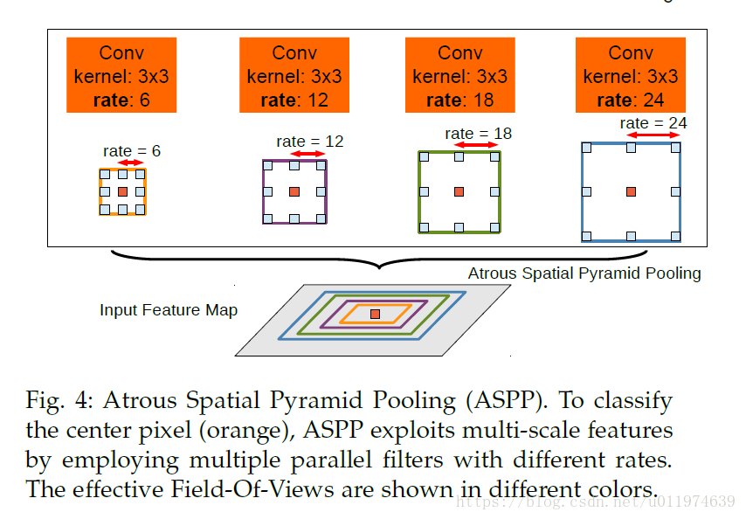

The atrous spatial pyramid pooling. To classify the center pixel, ASPP exploits multi-scale features by employing multiple parallel filter with different rates. The effective of Field-of-view are shown in different colors.